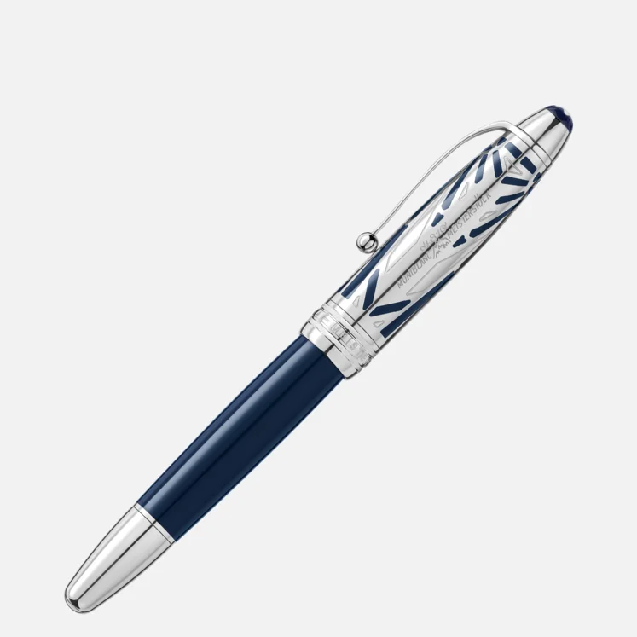

# MEISTERSTÜCK THE ORIGIN COLLECTION DOUÉ LEGRAND FOUNTAIN PEN F

The Meisterstück The Origin Collection Doué LeGrand Fountain Pen F combines a black resin barrel with a platinum-coated cap and a 14k gold nib, offering a luxurious and smooth writing experience. It’s a symbol of elegance and Montblanc’s heritage.

6of30

Show learn more suggestions